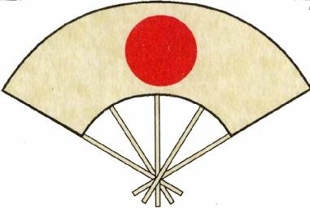
The British Kendo Association Jodo and Iaido
Level One Coaching Course

Information Pack
Roles and Qualities of a coach

The course will be led by

<coach_1> – <coach_level>
<coach_2> – <coach_level>
Introduction
The BKA is pleased to announce a Level 1 coaching course.
This course will be Iai/Jo Tutor led but is also open to Kendoka.
The course will run from <starttime> – <endtime>.

<dayName><dayNo.><month><year>
Closing date for Booking, application and course notes:-
<dayNo.><month><year>
Cost - £<cost> - Booking on BKA membership.

The Required Course/Delegate notes.
THESE WILL BE REQUIRED ON THE DAY.
Available from,
<cpo_name> - Coach Program Officer. Iaido/Jodo
at <cpo_email_address>

Venue
<address_1>
<address_2>
<city>
<county>
<postcode>

Tea and coffee facilities will be available but please bring lunch.

The Day involves a teaching session so it is advisable to wear loose clothing.
Hakama may be worn but is not essential.
Please bring Bokken/Jo as appropriate for the teaching session.
The Course.

The L1 course is aimed at those wishing to step up to the role of assistant coach and Dojo Leader.
It focuses on the Roles and Qualities these persons play in the Dojo. It reinforces the ideals of correct practice, Health and Safety and duty of care.
It also lays out the minimum requirements for you to fulfil these positions with a view to Risk assessment, must haves for Coaches, Dojo Administration and begins to focus on the importance of how teaching happens and how you go about teaching others, including warming up and cooling down.

KENDOKA are more than welcome to attend this course. When reading through the delegate notes where it states “Iaido/Jodo” read KENDO and for the teaching session an “IMPROVISED” KENDO KATA will be the requirement but only one side needs to taught, Shidachi/Uchidachi at the delegates discretion.

