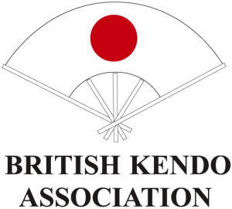

BKA Jodo INTENSIVE TRAINING

5th March 2017

Northampton

Musokan Dojo, Great Houghton Hall
High Street, Great Houghton, NN4 7AF
10:00 to 16:00
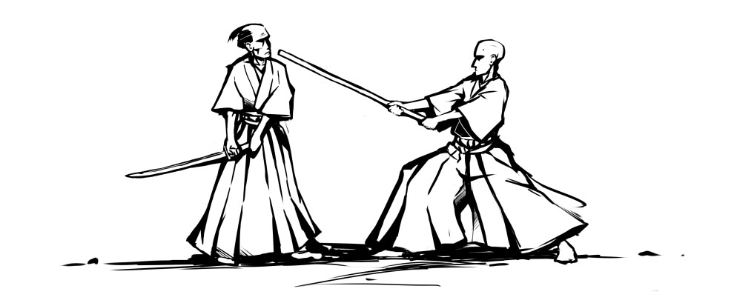

Open to all and intended for anyone wanting intensive seitei jodo training, we highly recommend attending this session - whether you are interested in being considered for the Jodo National Squad, or just wish to develop your seitei/taikai skills.
Fee: £15 full or £7.50 concession (payable on the day).
***Please bring the correct change!***

