BKA Jodo HIGH GRADE SEMINAR
(3rd dan and above)

18th February 2017

Kenmukan Dojo
Wolverton
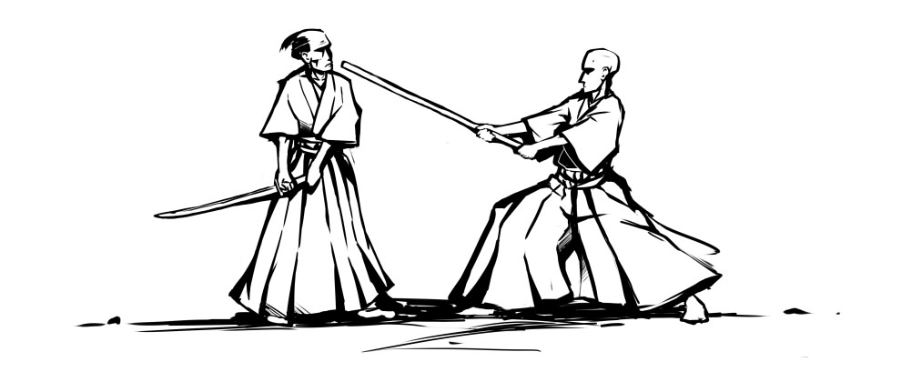

The seminar will be led by

Chris Mansfield
Jodo Kyoshi 7th Dan
Iaido Kyoshi 7th Dan

Venue

Millmead Hall
Haversham Road
Wolverton MK12 5TN
(opposite Wolverton Rail Station)

Car parking is available at the venue.

Catering Details: Please bring a packed lunch with you. Tea/Coffee making facilities available, please bring your own tea/coffee.

Schedule

09:30 | Registration
10:00 | Seminar starts
17:00 | Seminar finishes

Prices

We are providing a discount for those that book early. Concessionary rates apply to those in full-time study or are retired.

 | Early Booking  (Up to 4th February) | Late Booking
Full member | £30 | £35
Concessionary member | £15 | £20

Registration

Early booking is available until 4th February 2016.
All members are encouraged to use the online booking system as explained below.

BKA Members
Please book onto this event through the online booking system by going through your account at http://www.membership.kendo.org.uk/. You will need to add items to your basket and return to the booking screen to add accommodation nights, sayonara party booking etc, where relevant.
Please make sure that you have booked:
- The right seminar booking.
- The correct grading if you are grading.
If you have any problems with the online booking system, please contact Stojanka at jodo.bucho@gmail.com

Overseas visitors only
You can now book onto the event via the BKA website online registration system as a “guest” member.
To do this you will need to:
1. Go to the link http://www.membership.kendo.org.uk/html/guest_member_register.php
2. Make sure that you have logged out of any existing membership from previous years.
3. Register a User Name and Password, email address and submit.
4. You will receive a link in your email. Click on this to confirm.
5. You will be directed to a page to enter your full details.
6. You will then be allowed to book onto the events required (follow BKA members instructions from there on).
If you are unable to achieve this then please send an e-mail to Stojanka at jodo.bucho@gmail.com including your name, current grade and whether you intend to grade.

Cancellations and Refunds

Cancellations must be received in writing (letter or email) by Saturday 11th February for a full refund. If you do not cancel or do not attend the event, no refunds will be made. You can transfer your seminar place to another person providing the event organizer is notified, and that person completes an application form (this can be done on the day). Alternatively, by agreement, your fee can be transferred to the next event of equivalent cost.

Contacts

Jodo Bucho | Stojanka Vidinic | jodo.bucho@gmail.com
Jodo Events Officer | Kristina Poslusna | jodoeventsofficer@gmail.com

