NORTHERN Jodo & Iaido
SEMINAR & GRADING
5th & 6th November 2016
The Education Village and Darlington College,
Darlington
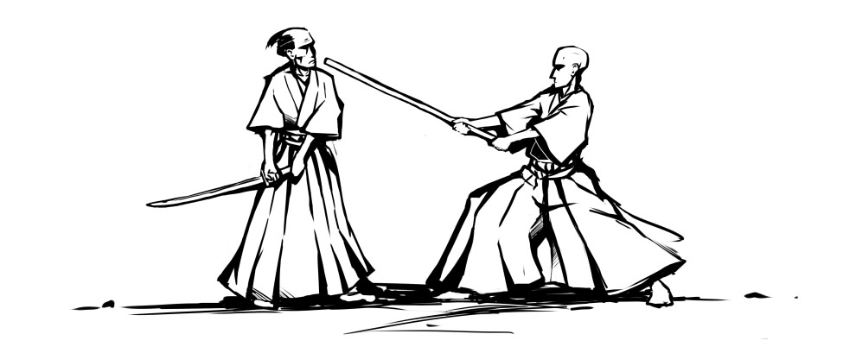

The seminar will be led by
IAIDO
Victor Cook Kyoshi 7th Dan
Fay Goodman Kyoshi 7th Dan
Chris Buxton Kyoshi 7th Dan
With Assistance from
Greg Drewe Renshi 6th Dan
Alan Lee Nash Renshi 6th Dan
Anna Stone Renshi 6th Dan
John Honisz Greens Renshi 6th Dan
Andy Watson Renshi 6th Dan
Hugh Darby 6th Dan

JODO
Harry Jones 6th Dan
with assistance from Stojanka Vidinic 5th Dan

Seminar
We would like to invite you to the BKA Northern Iaido and Jodo Seminar 2016. The seminar will be held simultaneously across two venues in the local area, the Education Village and Darlington College, which we have used in previous seminars, both offering a larger space to train and some smaller spaces for concentrated groups.

Venues
Venue 1 | Venue 2
Darlington College – University of Teeside Darlington Campus  Central Park  Haughton Road  Darlington  DL1 1DR  01325 503050 | Darlington Education Village,  Salters Lane South,  Darlington,  DL1 2AN  01325 254000

Grading
Gradings will be held on the Sunday afternoon in the Main Sports Hall, Education Village, grading up to yondan in iaido and up to sandan in jodo.
Please ensure you are aware of the new Iaido- and jodo-bu grading policy, recently published on the BKA website and sent to your dojo leaders by email.
Non-BKA members are requested to either a) register online through the seminar booking process and pay beforehand or b) inform the relevant grading officer of your wish to grade. You will also need to provide a letter of permission from your own federation to take part in the grading.
PLEASE NOTE - Grading applications must be completed and submitted to the Grading Officer no later than 1st November. This includes submission of a grading question paper.

Schedule
Saturday | Sunday
09:00 Registration  09:30 Seminar starts  17:00 Seminar finishes | 09:00 Halls open  09:30 Seminar starts  13:30 Registration begins for both gradings at Education Village Main Sports Hall  14:00 Gradings commence  17:00 Event closes

Car parking
Is available in both venues.

Public transport
Access by car is easy via the A1(M) and the A19. Darlington Train station is on the Main East-Coast line with most trains stopping there (London Kings Cross on a regular basis and it takes about 2h 30min). The venues are within 2 miles from the main train station.
Rail information can be obtained from the following website: www.nationalrail.co.uk
Access can also be reached by plane via Durham Tees Valley Airport which is only 6 miles from the venues.

Prices

We are providing a discount for those that book early. Concessionary rates apply to those in full-time study or are retired.
For the Iaido seminar:

 | Early Booking  (Up to 30th October) | Late Booking
Full member 2 days | £45 | £50
Full member 1 day | £25 | £30
Concessionary member 2 days | £20 | £25
Concessionary member 1 day | £10 | £15

For the Jodo seminar:

 | Early Booking  (Up to 30th October) | Late Booking
Full member 2 days | £50 | £55
Full member 1 day | £30 | £35
Concessionary member 2 days | £25 | £30
Concessionary member 1 day | £15 | £20

Catering Details:
Darlington College – no meals available but there are Dispensing facilities for snacks and drinks, please come prepared.
Education Village – the Canteen has been requested to be open 12.00-13.00 both days for the purchase of meals and drinks; if this is not possible, there is an Asda only minutes away.

Registration
Early booking is available until 30th October 2016.
All members are encouraged to use the online booking system as explained below.
BKA Members
Please book onto this event through the online booking system by going through your account at http://www.membership.kendo.org.uk/. You will need to add items to your basket and return to the booking screen to add accommodation nights, sayonara party booking etc, where relevant.
Please make sure that you have booked:
- The right seminar booking.
- The correct grading if you are grading.
If you have any problems with the online booking system, please contact John at iaido.bucho@kendo.org.uk or Stojanka at jodo.bucho@kendo.org.uk

Overseas visitors only
You can now book onto the event via the BKA website online registration system as a “guest” member.
To do this you will need to:
1. Go to the link http://www.membership.kendo.org.uk/html/guest_member_register.php
2. Make sure that you have logged out of any existing membership from previous years.
3. Register a User Name and Password, email address and submit.
4. You will receive a link in your email. Click on this to confirm.
5. You will be directed to a page to enter your full details.
6. You will then be allowed to book onto the events required (follow BKA members instructions from there on).
If you are unable to achieve this then please send an e-mail to John at iaido.bucho@kendo.org.uk or Stojanka at jodo.bucho@kendo.org.uk including your name, current grade and whether you intend to grade.

Cancellations and Refunds
Cancellations must be received in writing (letter or email) by Saturday 29th October for a full refund. If you do not cancel or do not attend the event, no refunds will be made. You can transfer your seminar place to another person providing the event organizer is notified, and that person completes an application form (this can be done on the day). Alternatively, by agreement, your fee can be transferred to the next event of equivalent cost.

Junior under 18
Juniors who are not with their guardians are assumed to be under the care of their Dojo Leader or Appropriate Adult. Please inform John Honisz-Greens at iaido.bucho@kendo.org.uk of the name of the responsible person.

Local Contact Details:
Lee Mountain at lkmountain@hotmail.com

