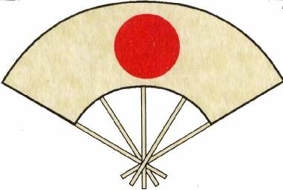

The British Kendo Association Jodo and Iaido
Level One Coaching Course

7th March 2020

Information Pack
Roles and Qualities of a coach

The course will be led by

Hugh Darby – Iaido Coach Tutor
Donnie Gordon - Iaido Coach Tutor

Introduction
The BKA is pleased to announce a Level 1 coaching course for both Jodo and Iaido
The course will run from 10:00 – 17:00.

The Required Course/Delegate notes.
Closing date for Booking and Notes – 21 February
Available from,
Martin Clark - Coach Program Officer.
at japaclark@aol.com

Venue
Yushinkan Dojo
Church Street
Dumbarton
Scotland
G82 1QQ

Tea and coffee facilities will be available but please bring lunch.

The Day involves a teaching session so it is advisable to wear loose clothing.
Hakama may be worn but is not essential.
Please bring Bokken/Jo as appropriate for the teaching session

The Course.

The L1 course is aimed at those wishing to step up to the role of assistant coach and Dojo Leader. It focuses on the Roles and Qualities these persons play in the Dojo It reinforces the ideals of correct practice, Health and Safety, Equity in your coaching and duty of care.
It also lays out the minimum requirements for you to fulfil these positions with a view to Risk assessment, Must have for Coaches, Dojo Administration and begins to focus on the importance of how teaching happens and how you go about teaching others, including warming up and cooling down

