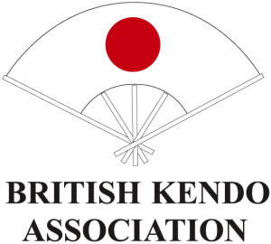

Iaido SQUAD TRAINING SESSIONS 2018
Information and Policy

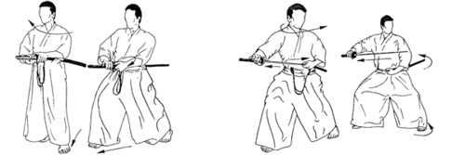

Karl Gibbons – Squad Manager

Welcome:
Squad Training Sessions (STS) are open to all BKA Iaido-bu members regardless of squad aspirations, grade or indeed ability. Despite the daunting name they are intended to help all members have more opportunities to develop their Iaido. The STS will be organised by the Squad Manager assisted by the Squad Coach and other nominated officers and invited seniors to focus on notable technical weaknesses or specific themes to better equip those in attendance to do more effective Iaido. The STS are not seminars, so explanations will aim to be short and to the point, so that more repetitive practice can be achieved with specific and quick one-to-one feedback given when needed.

Any BKA member can be considered for Squad selection and if anyone is interested in being considered for the 2018 Squad they must e-mail the Squad Manager and inform of the desire to be considered and confirm that they have read and agreed to the Code of Conduct. This means you will be monitored and receive point allocation for attendance and be given specific feedback and improvement will be moniored.

When emailing, please also listing your name, e-mail address, contact phone number, current grade, when you are next eligible to grade, and a summary of any national and/or international results (if available): Code of Conduct: http://www.britishkendoassociation.com/resources/

You can contact the Squad Manager on: karliaidoteammanager@yahoo.com

Only attendance at BKA Iaido events will be considered for squad selection and will be based on skill, enthusiasm, attendance, attitude, compatibility, and overall benefit to the Iaidobu through a member’s participation.

A points system will be used as an indicator of attendance and success and will be used in conjunction with a log of a candidate’s performance and development to select a final team. Squad and final team selection will be by democratic process involving the Team Manager, Team Coach and Bucho. The selectors’ decisions are final.

Event | Point Value
BKA Seminar Attendance | 1
Squad Training Session  (no points for half day attendance) | 2
Iaido Nationals Attendance | 3
Nationals Medal Win (Gold) | 6
Nationals Medal Win (Silver) | 4
Nationals Medal Win (Bronze) | 2

BRING A PAD AND PENCIL SO THAT YOU CAN MAKE WRITTEN NOTES OF ADVICE GIVEN

General Rules:
All team members are expected to behave in a manner which befits the art of Iaido. Members should remember that they are not only representing the BKA, but that they are sporting ambassadors for the United Kingdom before, during and after an event and particularly at any social event which they may be required or opt to attend. The Squad Manager will provide the squad and final team with a full code of conduct and expectations, befitting of an international competitor. Adherence to this is compulsory.

Team members are expected to co-operate and to assist in the building of team spirit. This will also factor into final team selection. The objective is to achieve the best performances in each event and to achieve, overall, the highest possible team and individual results, while also extended BKA membership exposure and benefits through EIC participation.

Important STS Dates:
 | Date | Proposed Area
Squad Training Session (1) | March 24th | Halesowen
Squad Training Session (2) | April 8th | Edinburgh
Iaido Nationals | May 26-27th | Stevenage
Squad Training Session (3) | June 24th | Northampton
Squad Training Session (4) | August 12th | Middleborough
Squad Training Session (5) | September 22nd | Sheffield
Squad Training Session (6) | October 20th | Halesowen
European Iaido Championship | Oct | Poland

Cost:
The cost to attend STS is £15 (or £10 concession rate). No half-day rate is available to members. This rate is charged to assist cover hall-hire and pay modest expenses. Please pay on the day of the event in cash and bring the exact amount. Excess funds will be used to support squad only sessions and for sending our final team to the EIC.

Updates and venues will be posted on:

BKA website: http://www.britishkendoassociation.com
BKA calendar: http://www.britishkendoassociation.com/calendar/
BKA Facebook: https://www.facebook.com/groups/britishkendoassociation/

In closing, to every person in the Iaidobu please take this as an open invitation for you to attend UK Squad Training Sessions in 2018; to help improve your Iaido, and if you desire to challenge for a squad place and represent your country.

You can contact the Squad Manager on: karliaidoteammanager@yahoo.com
…..

COMMUNICATION POLICY and FACEBOOK:
If you have an enquiry regarding Bu operations then please email the relevant Bu Officer/s directly, making sure that all relevant persons are included and named. Thus, if an issue is Iaido only then address your concern to the Iaido Officer/s. If it involves other Bu or NC Officers, then be sure to include them and add them in your salutation making sure all relevant Officers are addressed for clarity.

Although the BKA webpage, E-mail and Facebook will be utilised by the Bu Officers to put poster and advertisements of Bu activity for members, Facebook is not what we consider our official or an appropriate method for answering enquiries. Not all Officers, faculty or indeed members use Facebook (or similar media). Questions posted on Facebook will not be addressed, so please send direct Email to avoid disappointment or confusion. The Iaido Officers email addresses are available on the BKA webpage.

