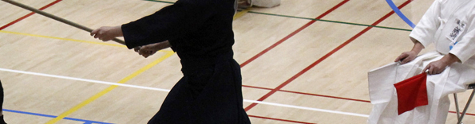

BKA Jodo National championships 2017
^{10th June 2017}

Dear Jodobu Members
We are delighted to invite you to this year’s National Jodo Championships. Please find below all the information necessary to make your entry. We look forward to seeing you at this event.

Stojanka Vidinic
Jodo Bucho

Venue  Soar Valley Leisure Centre  Off Kingfisher Road  Mountsorrel  Leicester  LE12 7FG  Tel: 01162 375 267  Programme – Saturday 10th June 2017  09:00 Hall opens  09:30 Registration  10:00 Taikai opens  12:30 Lunch  13:15 Taikai continues  Day will close with award presentation and extra training if time permits  17:00 Venue closes  Prices  Individuals £10  Two-person team £20  Asahi three-person team £25 | How to enter  Please fill out the form on the following page. Ideally, for a dojo this should be filled out by one person. If you are entering by yourself without your dojo then of course please fill this out as well.  Please post entry and cheque made out to:  British Kendo Association (22097982)  And post to:  Stojanka Vidinic  53 Puteaux House  Mace Street  London E2 0RF  AND Please email a copy of your entry to Andy Watson at ryoshinkancho@gmail.com  The final entry must be made by the 3rd of June.

CANCELLATION AND REFUND
Cancellations must be received in writing (letter or email) by 4th June for a full refund. If you do not cancel or do not attend the event, no refunds will be made.

Dojo Name:_______________________Contact name:________________________________

Contact no:_______________________Contact email: _______________________________
Jodo Individual Competition entries at £10 per entry
Competitors List
Name | Grade | Fee
Jodo Dojo Two Person Team Competition entries at £20 per team entry
Competitors List (maximum number of dan’s added together is 7: mudan = shodan = 1)
Name | Grade | Fee
Competitors list Team A
1.
2.
Competitors list Team B
1.
2.
Competitors list Team C
1.
2.
Asahi Jodo Three Person Team Competition entries at £25 per team entry
Competitors List (maximum number of dan’s added together is 5: mudan = shodan = 1)
Name | Grade | Fee
Competitors list Team A
1.
2.
3.
Competitors list Team B
1.
2.
3.
Competitors list Team C
1.
2.
3.

TOTAL FEE DUE____________

