Jodo & Iaido
Summer Seminar 2015
and Bunka Koryu Enbusai
英国夏講習会文化交流演武祭

IAIDO SEMINAR 8th – 10th August
JODO SEMINAR 11th – 13th August

The seminars will be led by

Ishido Shizufumi Sensei Iaido Hanshi 8th dan, Jodo Kyoshi 8th dan
Morita Tadahiko Sensei Iaido Kyoshi 8th dan
Oshita Masakazu Sensei Iaido Kyoshi 8th dan
Otake Toshiyuki Sensei Jodo Kyoshi 8th dan, Iaido Kyoshi 7th dan
Shoji Kei'ichi Sensei Jodo Kyoshi 8th dan, Iaido Kyoshi 7th dan
Yoshimura Ken'ichi Sensei Iaido Kyoshi 8th dan, Jodo Kyoshi 7th dan
Matsuoka Yoshitaka Sensei Iaido Kyoshi 8th dan
Kinomoto Miyuki Sensei Iaido Kyoshi 7th dan
Aoki Hidekiyo Sensei Iaido Kyoshi 7th dan

It with great delight to announce this year’s Jodo and Iaido Summer Seminar which will incorporate the Bunka Koryu Enbusai to commemorate 35 years of summer seminars in the UK and 10 years since we hosted the World Iaido Goodwill Taikai. This event will give us the opportunity to train in Seitei, there will also be the opportunity to train Koryu with the various teachers that we are inviting from Japan.

The following styles will be represented:

- Muso Shinden Ryu
- Muso Jikiden Eishin Ryu
- Shinkage Ryu
- Suio Ryu
- Shinto Muso Ryu Jojutsu (Tokyo and Fukuoka style)

In addition, along with the teaching delegation will come several demonstrators who not only represent a range of Koryu but have also seen various levels of success in ZNKR taikai. With this in mind we are hoping to make this a memorable and enjoyable event with a distinct focus on Koryu Jodo and Iaido. To mark the event we have dedicated a whole additional day to Koryu training and a Koryu embukai so that we can all challenge ourselves to demonstrate what we have learned over the duration of our training.

Venue
Once again in order to make accommodation cheap and easy to book we have continued to support Stevenage Arts and Leisure Centre. The extended training area should give us ample room.

Stevenage Arts and Leisure Centre, Stevenage, SG1 1LZ – typing this postcode into Googlemaps will give you the correct location.
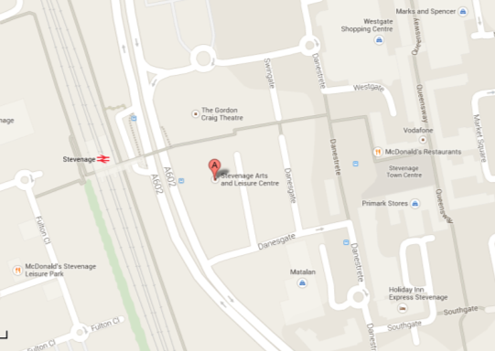
Both dojos are located on the ground level of the centre.

Seminar
The events will take place according to the following schedule:

Date | Event
08-Aug-15 | Iaido Seitei Seminar & Grading
9-Aug-15 | Iaido Koryu Seminar
10-Aug-15 | Iaido Training & Embu Taikai
11-Aug-15 | Jodo Seitei Seminar & Grading
12-Aug-15 | Jodo Koryu Seminar
13-Aug-15 | Jodo Training & Embu Taikai

The timings for each day are as follows:
- 09:00 Registration
- 09:30 Seminar morning session
- 12:30 Lunch
- 14:00 Seminar afternoon session
- 17:30 Seminar close

Those who are taking a grading should (as is always the case) ensure they are prepared to grade before arrival at the event.

Grading
For both disciplines the gradings will occur on the first day of the 3-day seminar:
- Iaido grading will be on Saturday 8th August up to and including 5th Dan.
- Jodo grading will be on Tuesday 11th August up to and including 5th Dan.

BKA members are requested to register online. The grading application process will close by:
Iaido: 24th July 2015
Jodo: 28th July 2015
Non-BKA members are requested to either a) register online through the seminar booking process and pay beforehand or b) contact the relevant grading officer and pay for registration and menjo on the day of the grading. You will also need to provide a letter of permission from your own federation to take part in the grading.
For the Iaido Grading Officer: Dave Fanning iaido.grading@kendo.org.uk
For the Jodo Grading Officer: Daniel Silk daniel.silk82@gmail.com

Car parking
Is available in the various pay-and-display car parks in the area. There is a car park behind the Leisure Centre and a multi-storey car park at the end of Danesgate.
Public transport
Access by car is easy via the A1(M). Trains run from London Kings Cross on a regular basis and the express train takes only 26 minutes.

Rail information can be obtained from the following website: www.nationalrail.co.uk
Other transport options include www.nationalexpress.com for coach services within the UK.

Accommodation and Eating Out
There are various hotels located around Stevenage and most are easily in walking distance. The closest hotels to the venue that it is suggested you try are:
- Ibis, Stevenage
- Holiday Inn, Stevenage
- Holiday Inn Express, Stevenage

Please follow this link for a map to the accommodation and eating places that we are familiar with:

https://www.google.com/maps/d/edit?mid=zwu50UP3_w88.kVgO6UFLA4-g

Prices
Due to the large number of Japanese teachers and embusha we are inviting this year we are having to increase prices compared to previous years. There is a discount for those that book early. Concessionary rates apply to those in full-time study, unemployed or retired.

For either seminar:

 | Early Booking  (Up to 31st May) | Late Booking  (From 31st May to 7th August)
Full member 3 days | £115 | £125
Full member 2 days | £85 | £95
Full member 1 day | £50 | £60
Concessionary member 3 days | £55 | £65
Concessionary member 2 days | £45 | £55
Concessionary member 1 day | £35 | £45
Sayonara Party | £25
Sayonara Party
The Sayonara Party will be held at the Holiday Inn Hotel on Monday 10th August. We have booked a 3-course sit-down meal for £25 per head, drinks paid separately. Following dinner there will a DJ and dancing till late. Please note that the venue is the Holiday Inn and not the Holiday Inn Express.
A walking route is shown below (please go through the underpass to cross St Georges Way):
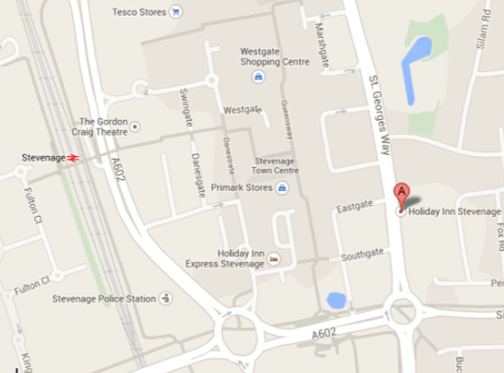

Please book and pay online via the event “BKA Iaido and Jodo SumSem Sayonara Party 2015”, remember to choose one starter (from the first drop-down menu) and one main and one dessert (from the second drop-down menu). There is a vegetarian option for all three courses. Further information for booking your courses is shown on page 7 of this pack. The menu is as follows:

Anti Pasti Plate; Parma Ham, Milano Salami with Bocconcini Mozzarella, Olives and cherry tomato served with dressed rocket leaves
Butternut Squash Soup with Sage and Orange Blossom Honey
***
Four cheese torteloni with Spinach and Parmesan sauce (V)
Chicken and Bacon roulade stuffed with garlic mushrooms served with dauphinoise potatoes, seasonal vegetables and a red wine jus
***
Fresh Dairy cream profiteroles with dark chocolate sauce
Lemon torte with Raspberry coulis

If you have any other dietary requirements please select the other dietary requirements options for all three courses and email Harry Jones with what your specific requirements are at mrsmmiggins@yahoo.com. We will endeavour to accommodate your request but please note this may not be possible or may incur an additional charge.

Registration
Early booking is available until 31st May 2015.
All members are encouraged to use the online booking system as explained below.
BKA Members
Please book onto this event through the online booking system by going through your account at http://www.membership.kendo.org.uk/. You will need to add items to your basket and return to the booking screen to add accommodation nights, sayonara party booking etc, where relevant.
Please make sure that you have booked:
- The right seminar booking.
- The right booking for the sayonara party.
- The correct grading if you are grading.
If you have any problems with the online booking system, please contact Andy at iaidobucho@gmail.com

Overseas visitors only
You can now book onto the event via the BKA website online registration system as a “guest” member.
To do this you will need to:
1. Go to the link http://www.membership.kendo.org.uk/html/book_events.php
2. Click on the text at the bottom of the page “Members of non-UK EKF/IKF etc”
3. Register a User Name and Password, email address and submit.
4. You will receive a link in your email. Click on this to confirm.
5. You will be directed to a page to enter your full details.
6. You will then be allowed to book onto the events required (follow BKA members instructions from there on).
7. If you had a previous guest membership which has now expired then please create a new one using a different user name and with a slight variation to your first name or surname.

Still having problems getting registered?
Go to https://www.facebook.com/notes/andy-watson/bka-guest-membership-problems-and-solution/10151670854679326 for more help!

If you are unable to achieve this then please send an e-mail to Andy at iaidobucho@gmail.com including your name, current grade and whether you intend to grade.

Notes
1. All participants from outside the UK should ask for a covering letter for the group/individual for carrying swords in and out of the UK. Please contact Chris Buxton at chris@cbuxton.plus.com
2. If you do not receive a confirmation email within two weeks check your spam, bulk or junk mail folders. If you find the email there, your ISP or your own software spam-blocker or filters are diverting our e-mail.

Booking your courses for the Sayonara Party

Please follow the process below for booking your courses for the Sayonara Party:

1. Book your starter from the upper drop-down menu. | 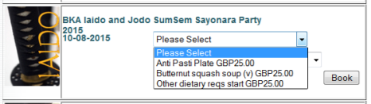
2. Book your main course or your dessert from the lower drop-down menu. | 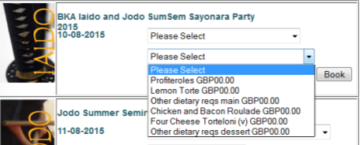
3. From this point you now need to click on the “Book” button to take you to the Shopping Cart (see image right). | 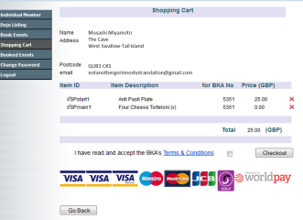
4. Now click on the “Go Back” button on the bottom left of this page.
5. You can now go back to the Book Events page, to the Sayonara Party event and add your dessert (or main course if you clicked on your dessert at step 2. | 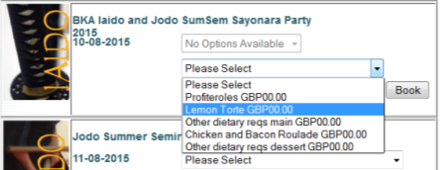
6. Click on the “Book” button again to take you once more to your Shopping Cart where you should be able to see your three courses and the total fee (if this is zero then you have done something wrong). | 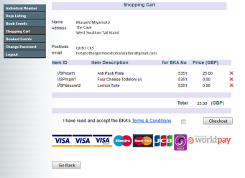
7. You can remove any courses you want to change by clicking on the red X next to each course. When you are ready to pay, click on the terms and conditions box and click on “Checkout”.

Cancellations and Refunds
Cancellations must be received in writing (letter or email) by 25th July 2015 for a refund minus transaction costs. If you do not cancel or do not attend the event, no refunds will be made.

Junior under 18
Juniors who are not with their guardians are assumed to be under the care of their Dojo Leader or Appropriate Adult. Please inform Andy Watson at iaidobucho@gmail.com of the name of the responsible person.

If you have any enquiries please email:

Al Colebourn for the Jodo seminar at alcolebourn@gmail.com
or
Andy Watson for the Iaido seminar at iaidobucho@gmail.com

For further social information and to enjoy the chat please come to our Facebook page at:
https://www.facebook.com/events/1527802617478138/

